ITCS 1010 Programming Logic

Logic Plan 4 – Chapter 4 – 20 points

“Calculate Software Sales using IF/Else Logic”

Student Name ____________Steven Woodard________________

Given the following problem statements, perform the steps and answer the questions listed below, which are designed to help you analyze the problem and prepare a strategy for solving the problem. Submit this logic plan and C# Project into a folder, zip the folder, and submit in Blackboard for grading.

Create a file folder on your USB Port drive or hard drive at home, and call it “Logic Plan4 Your student name”. For example “Logic Plan4 DLohn”.

There is no VideoNote associated with this Lab.

Problem statement: A software company sells a package that retails for $99.00. Quantity discounts are given according to the following table:

Quantity Discount
10-19 20%
20-49 30%
50-99 40%
100 or more 50%

Design and create an application that lets the user to enter the number of packages purchased. This program should then display the discount rate, the amount of discount, if any, and the total amount of the purchase after the discount in output label controls. Also, include an Exit button so the user can close the form, and include your student name, and include a proper title in the Title Bar of the form. Also, include a user-friendly Tool Tip on the Calculate button.

Use label controls, button controls, and program comments where applicable. Make sure the C# program is free of syntax and logic errors.

Example screen design:

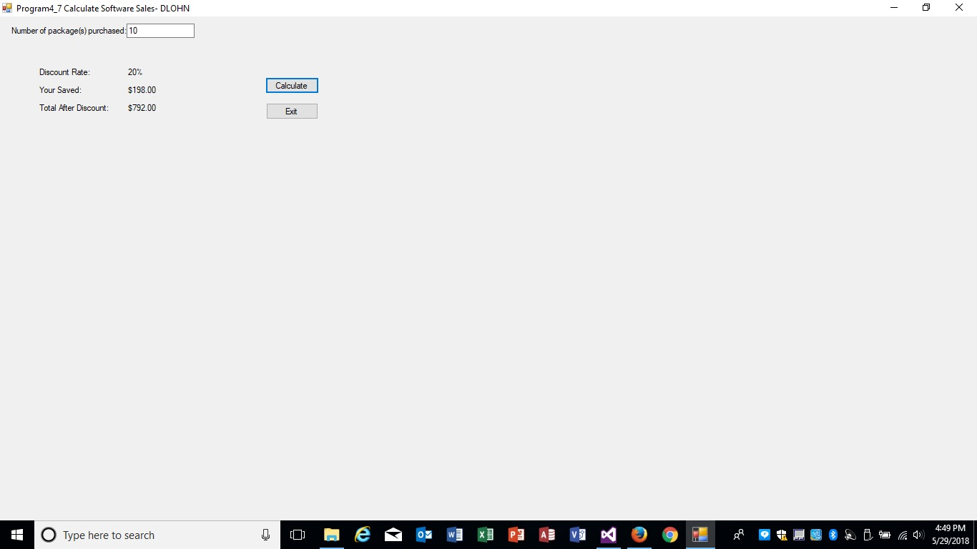

Before coding the program, design the Program’s Logic: enter your answers in the IPO chart below. Write pseudocode and insert below. Draw a flowchart and insert below. (Hint: reference the Tutorial 4-2 Logic Plan found in this Tutorial!)

What must the user enter as INPUT?
INPUT
QUANTITY:
0, 10, 20, 50, 100

How will the program calculate the amount of the discount, if any, and the total amount of the purchase after the discount?
PROCESSING
PARSE THE NUMBER
IF QUANTITY <= 0 NO PROCESSING
IF QUANTITY >= 1 && QUANTITY < 10 //1 TO 9 NO DISCOUNT
IF QUANTITY >= 10 && QUANTITY <= 19 //20% discount between 10 and 19
IF QUANTITY >= 20 && QUANTITY <= 49 //30% discount
IF QUANTITY >= 50 && QUANTITY <= 99 //40% discount
IF QUANTITY <= 99 //50% discount
EXAMPLE (10):
total before purchase: 990.00 = 99 * 10
amount of discount: 198.00 = 990.00 * .2
total: 782.00 = 990.00 – 198.00

What OUTPUT will the program display?
OUTPUT
DISCOUNT RATE, AMOUNT OF DISCOUNT, TOTAL AFTER DISCOUNT
EXAMPLE:
$990.00
-$198.00
$782.00

ENTER PSEUDOCODE HERE the pseudocode you wrote below in this Word document for grading.
DECLARE THE VARIABLES
INT QUANTITY
CONST DEC Package = 99.00M;
DEC DISCRATE = 0;
DEC AMTOFDISC = 0;
DEC TOTAL = 0;
GET THE USER INPUT, QUANTITY OR NUMBER OF PACKAGES
Parse, Keep out garbage tryparse

PROCESSING, CALCULATE TOTAL, DISCOUNT, TOTAL AFTER DISCOUNT
IF QUANTITY <= 0 NO PROCESSING
DISCRATE = 0
IF QUANTITY >= 1 && QUANTITY < 10 //1 TO 9 NO DISCOUNT
DISCRATE = 0
IF QUANTITY >= 10 && QUANTITY <= 19 //20% discount between 10 and 19
DISCRATE = .20m
IF QUANTITY >= 20 && QUANTITY <= 49 //30% discount
DISCRATE = .3m
IF QUANTITY >= 50 && QUANTITY <= 99 //40% discount
DISCRATE = .4m
IF QUANTITY <= 99 //50% discount
DISCRATE = .5m

TOTAL = QUANTITY * PACKAGE
990.00 = 10 * 99

AMTOFDISC = TOTAL * DISCRATE
198.00 = (990.00 * 0.2)

TOTAL = TOTAL – AMTOFDISC
792.00 = 990.00 – 198.00
DISPLAY OUTPUTS: DISCOUNT RATE, AMOUNT OF DISCOUNT, TOTAL AFTER DISCOUNT
EXIT TO CLOSE FORM

DRAW OR COPY/PASTE FLOWCHART HERE the flowchart you designed below in this Word document for grading:
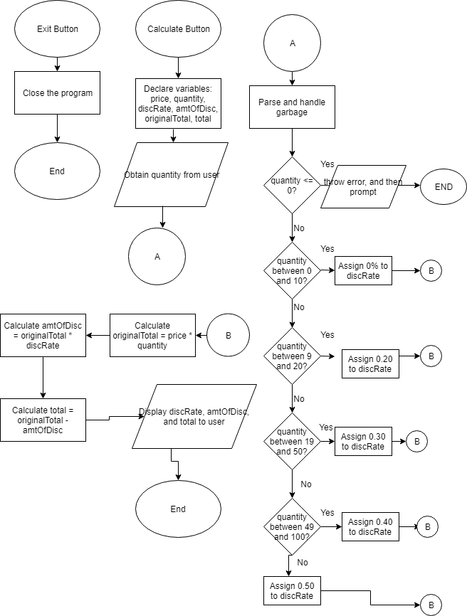

Save this project in your “Logic Plan 4 your student name” file folder and submit in this category for grading.

